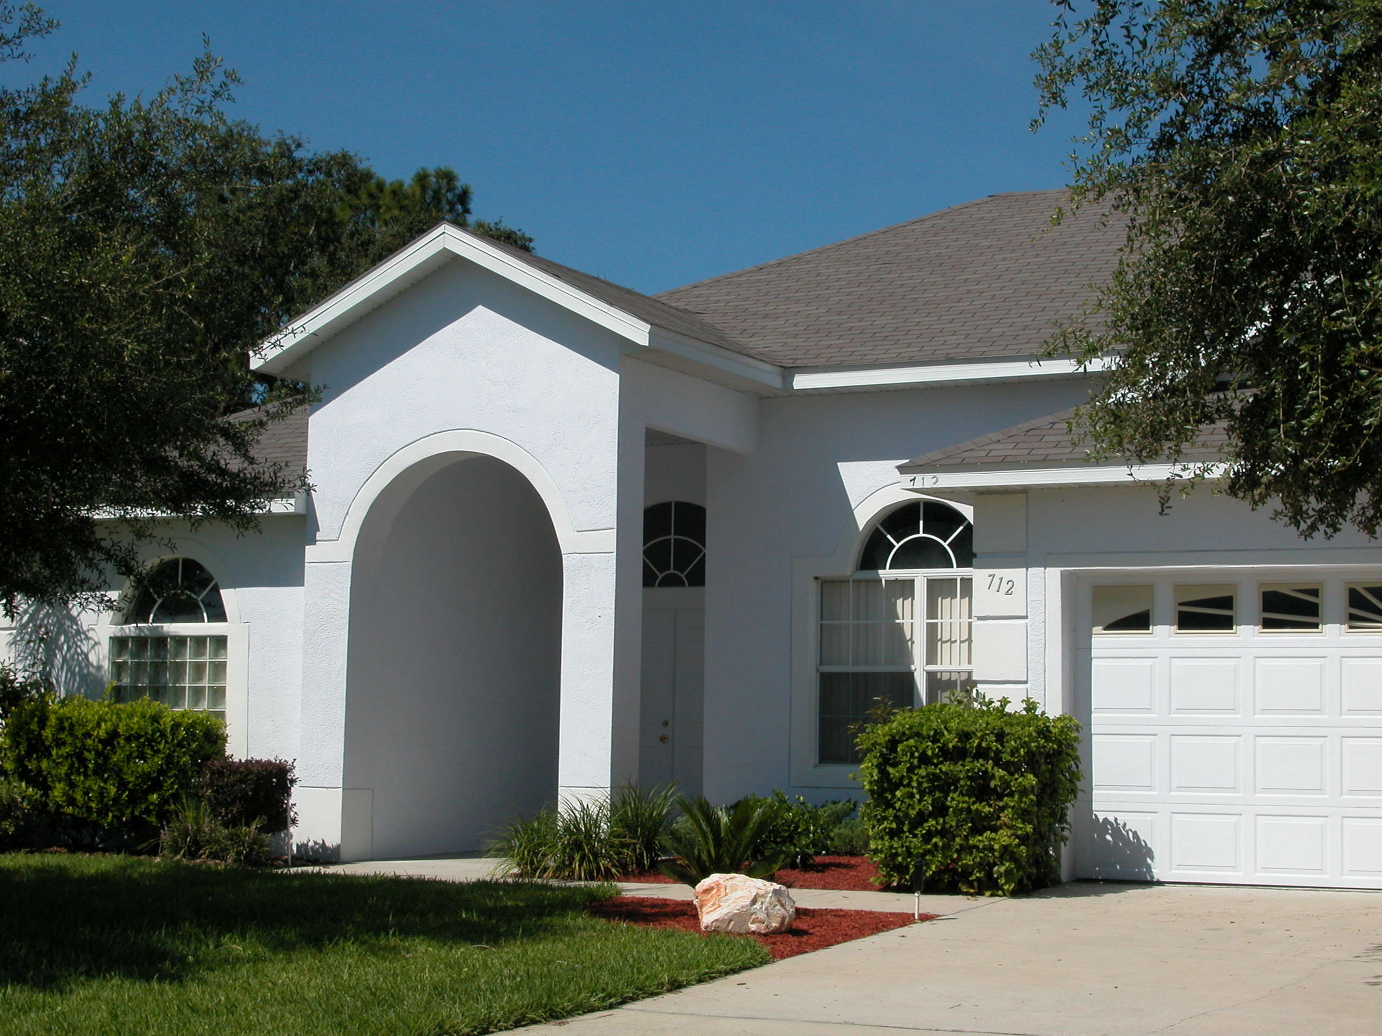

Welcome to your Florida Vacation Home.
We hope that you will enjoy your vacation here and take home many happy memories.
The information in this folder has been compiled to help you make the most of your stay.
Please try to find time in what we’re sure will be a very busy schedule, to read it.
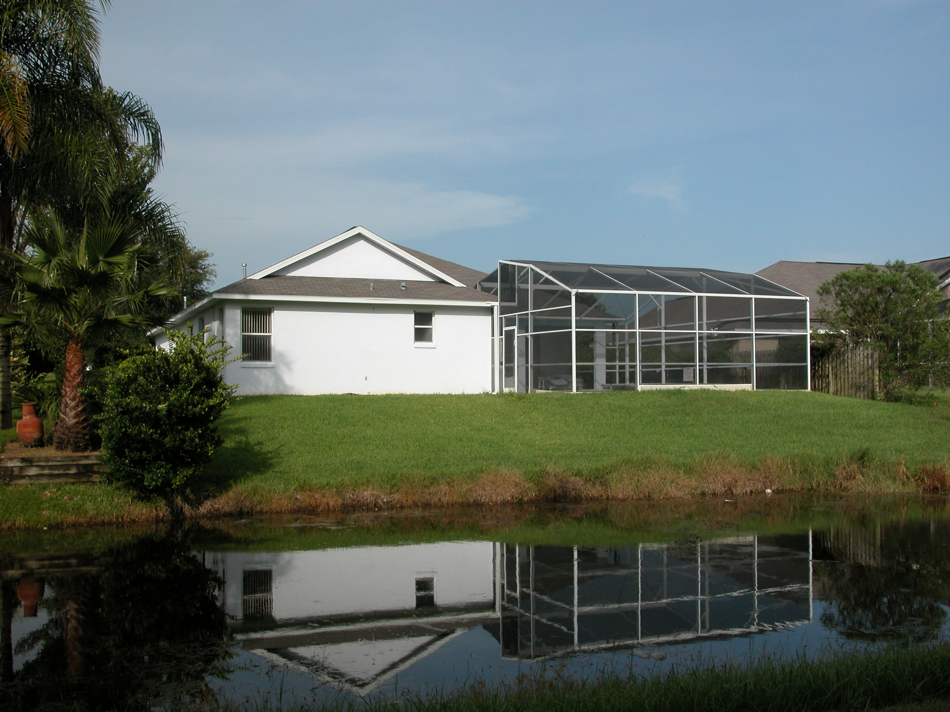
Useful Information
Air Conditioner 3
Appliances (instruction manuals) 3
Baby/Infant Equipment 3
Barbeque 3
Bathrooms 4
Breakages 4
Check-out 4
Cleanliness/Bugs 4
Cooker 5
Dishwasher 5
Electricity 5
Fan 5
Fire Extinguisher 5
First Aid kit 5
Games Room 6
Hair Dryer 6
Ice Maker/Water Dispenser 6
Intercom, radio and music system 7
Internet Access 8
Iron 8
Jacuzzi/Spa 8
Lamps 9
Mail Box 9
Management Company 9
Microwave 9
Outdoors 9
Pool 11
Poolguard Door Alarms 12
Restaurants and Cafes 12
Rubbish/Trash 13
Security 13
Smoking 14
Sony Playstation 2 14
Sunbathing 14
Telephone 14
Television and DVD/CD’s 14
Toilets 15
Towels 16
Vacuum Cleaner 16
Washer/Dryer 16
Waste Disposal Unit 16
Water 16

Air Conditioner
The air conditioner should ideally be set to approximately 75-80 Fahrenheit. If it is set too cold (lower than 72 deg) the unit will freeze and the home will become very warm as it will no longer work. If the unit is frozen a charge will be made for repairs.
Please try to keep all external doors closed to aid in keeping a reasonable internal temperature and also to avoid having a variety of unwelcome flying guests indoors!! Local lizards are very friendly creatures but don’t like to be trapped indoors!
In the winter months the air conditioner may be set to warm the home instead of cooling it. On the control box (on the wall in the family room by the entrance to the two twin bedrooms) set the lever to Heat instead of Cool.

Appliances (instruction manuals)
All instruction manuals are filed in a blue ring binder which can be found in the central drawer of the kitchen unit next to the refrigerator.

Baby/Infant Equipment
A travel cot, stroller and high chair are provided free of charge for our guests who are on holiday with a baby or very tiny infant. They are stored in the wardrobe of the twin bedroom on the right and in the laundry room.
Please leave them clean and pack them away again into the wardrobe after use.

Barbeque
A gas barbeque is provided which may be used at your own risk. We accept no responsibility for accidents or injury caused by its use.
Please make sure that it is positioned on the drip mat provided otherwise fat and juices from cooking may run into the pool and cause damage.
There may be gas left in the cylinder from a previous guest. However, we do not provide gas and when the gas cylinder is empty please take it to Lowes or Walmart where it may be exchanged for a full cylinder at a cost of approximately $16. The nearest Lowes/Walmart is north on highway 27 just north of the junction with the 192.
Please leave the barbecue in a clean state such as you would like to find it ready for your own next use. A charge will be made for cleaning it if it is left dirty and also for cleaning the pool area if the drip mat is not used.

Bathrooms
All bathrooms are fitted with extractor fans.
You may be unfamiliar with the plugs and fittings in bath and washbasin. To lock the plug simply pull up the knob located behind the tap and push it back down to drain the water. Some taps turn on by pulling on the tap others by twisting. Temperature is controlled by twisting the tap.
A spray shower cleaner is provided in each bathroom. A quick spray after use will keep the shower smelling fresh and shiny. No need to wipe – just a quick spray!
In the master bathroom a non-slip step is provided for those who may need help gaining access to the large corner bath and shower unit as the entrance is quite high.
Plain coloured bath and hand towels and patterned pool towels are provided for your use while staying in our home. Please do NOT use these towels for visits to the beach!

Breakages
Please advise the management company of any breakages, or damages such as tears, burns or stains. We do appreciate that accidents will happen but it is much easier for all concerned if we know about them so that they can be dealt with promptly.

Check-out
Please vacate the property by 10 am on the day of departure. Late departures must be arranged in advance and may suffer a surcharge.

Cleanliness/Bugs
Ants and other unwanted pests are common in Florida. The property is sprayed regularly to minimise their appearance but you will have less trouble with them if you:
- Do not leave food out – please wipe down counter tops and store unused food in the refrigerator
- Do not leave dirty dishes
- Do not leave dirty clothes on floors (ants particularly like damp swimsuits and they do eat clothing!)
- Do not eat in bedrooms
- Do not leave doors and windows open
- Use the vacuum cleaner provided to pick up crumbs around tables and anywhere food has been consumed.

Cooker
The cooker is electric. It has a large oven with integral grill and four hobs. The oven will beep once when it is at pre-heat temperature. Do not slide the locking lever to the right when using the oven to cook as this puts the oven into auto-clean mode.
A variety of cooking pots, pans, Pyrex and Corningware oven to table dishes are available for your use – they are in the kitchen cupboards and baking trays can be found in the drawer beneath the oven.

Dishwasher
All cutlery and crockery provided is dishwasher safe. The wine glasses will need to be angled if you wish to wash them in the dishwasher as they are too tall to stand upright.

Electricity
Voltage in USA is 110 volts. The plugs appear to have two identical pins but in fact on most appliances the two pins are of different size and will only fit into the socket one way round. The larger pin is placed to the left. Should you experience difficulty trying to insert a plug please turn it through 180 degrees and try again.

Fan
A ceiling fan is installed in the family room. This can be used with the air conditioning in the summer and also with the heating in winter, when it helps to circulate the cool or warm air throughout.

The fan is turned on with the left hand switch on the archway by the middle bathroom. The pull cord changes the rotation mode between fast, medium, slow and off – use the slow position when heating so as not to create a draft.

The master suite is also fitted with a fan over the bed.

Fire Extinguisher
A fire extinguisher is provided. It is located in the kitchen by the door to the laundry room. Please take the time to familiarise yourself with its location and use. Instructions are provided in the Welcome manual in the Villa and a plan of the villa is on the wall by the front door.

First Aid kit
A First Aid box is located in the tall kitchen cupboard.

Games Room
The games room is provided for your enjoyment. Please use it safely and ensure that children are accompanied by a responsible adult at all times. This is a no smoking area just like the rest of the villa.
It has been converted from the original garage and is home to the water heater boiler, air conditioning furnace (for heating in the winter) and electricity fuse box. These items are a danger to small children who, as we all know, are very curious and often poke fingers into places they shouldn’t.
Equipment provided includes pool, air hockey and table soccer tables, an electronic dart board, a television with Sony Playstation 2 and a selection of jigsaw puzzles and board games. Please ensure the Playstation is switched off when leaving the room otherwise the fan runs continuously to try and cool the unit and it may burn out.
A wall mounted fan is provided to keep you cool while enjoying a game but please ensure it, and all lights, are turned off when you leave the room. The fan turns on by pressing the switch in the centre of the base plate which has the word SPEED on it. The pull cord simply adjust the rotation.
The pool/air hockey table flips over from one game to the other. To turn the table top you must lower the four levers (two at each end of the table) rotate the table top and then raise the levers to their original position to lock the top in place again.
The door from the games room to the laundry and kitchen should never be left open as the air conditioning for the rest of the villa may then fail. This door is also one of the main external doors and should always be locked at night and any time you leave the villa unoccupied.

Hair Dryer
A hair dryer is stored in the under sink cupboard in every bathroom.

Ice Maker/Water Dispenser
The freezer compartment of the refrigerator has an automatic ice maker and dispenser with crushed ice option. Be prepared for random noises like corn popping and water running!! There is also a chilled, filtered water dispenser. Florida tap water is drinkable but has an unusual taste however, once filtered and chilled it tastes much more like the water you may be used to.

Intercom, radio and music system
Our NuTone home intercom system with built-in CD player, and AM/FM tuner allows you to communicate with visitors at the front door and also every internal bedroom and the lanai.
Music or radio can be played in any room of your choice, or all rooms simultaneously. The timer can be set to awaken everyone at the same time so no-one holds up the party’s departure for the theme parks!
The intercom system also functions to monitor sounds between rooms for example as a baby alarm. There is a privacy option in each room so you do not need to worry about people in other rooms overhearing your conversations.
The master unit is on the wall in the kitchen.
To choose a location gently lower the bottom panel of the master unit and you will see a row of switches each of which can be set to radio and intercom, intercom only, off or monitor.
Switches 1 to 5 are used for:
- Lanai
- Master bedroom
- Bedroom 2 on the floor plan (right one of the twin rooms)
- Bedroom 3 on the floor plan (left one of the twin rooms)
- Bedroom 4 on the floor plan (secondary master suite)

Internet Access
High speed wireless internet access is freely available 24 hours a day – just bring along your laptop/tablet with wireless network card (or regular network card and an Ethernet cable). The router and switch are situated in the family room, on the shelf either side of the DVD player. If you are going to connect with a regular card and Ethernet cable please make sure you bring a long one so that you can situate yourself comfortable to work or browse the internet.
The router runs DHCP so just plug in your Cat 5 cable or if you use a radio LAN our settings are:
Wireless Network Name (SSID): MyFloridaVacationVilla
Network encryption key (WEP64-hex): 71FF71FF71

If you have any problems connecting:
The switch on the distribution board to the right of the television (behind this picture frame) will switch off both the router and modem. Wait for a minute or two and then switch it back on to reboot them. After all the lights settle down you should have no further problem connecting.

Iron
An iron and ironing board can be found on the shelf in the washroom. Please be sure to empty out all water and turn it off when not in use.

Jacuzzi/Spa
The spa is the small area at the far end of the pool. The jets are operated by pressing down on the round black switch that is located to the centre of the pebbled area behind the spa.
One press turns the jets on and another press turns them off. It may be necessary to wait approximately 5 seconds after the first press for the jets to start bubbling. Please do not repeatedly press the switch as this will break it.
When pool heating is active the water in the spa area and more specifically from the jets will be slightly warmer that the water in the pool.

Lamps
Table lamps are provided in each room. The on/off switches are found at the top of the base and they should be twisted twice clockwise to turn on and again in the same direction to turn off. The lamp furthest from the door in each room may be turned on/off by the light switch near the door – if it appears not to work try switching on the light switch by the door. Please note that Up is the on position and Down is off!

Mail Box
The mail box is at the end of the drive. Free local papers are delivered several times a week and they are very useful sources of information about local events/shops etc. Please do open the mail box and take them out for your own use while you’re here. Newspapers can be recycled in the yellow recycling box (in the garage) which should be put out for collection with the trash on Thursdays only. Should there be any mail addressed to us please could you put it into a kitchen drawer.
Sending mail/postcards – just pop your mail into the mailbox and raise the red flag. It will be collected the next day by the postal service and the flag replaced in the lower position. Stamps are available at all supermarkets.

Management Company
Should you have any problems with anything in the home please contact Ron or Leslie at Reliance Care Services on 863-984-9676 or for any emergency with appliances, pool or general maintenance 863-521-2298.

Microwave
The microwave is fairly easy to use and the timer works efficiently for timing things cooked on the regular cooker.
There is a hob light which is also activated on the Microwave control panel. Press the switch once for a bright light to see what’s cooking or twice for a gentle overall light.
The air vent\extractor fan is operated by pressing the Hi/Lo/Off toggle button.
For a complete list of cooking times and full instructions please refer to the manual in the kitchen drawer.

Outdoors
Take care in grassy areas. Advise children about fire ants (they build nests underground and appear in sand mounds). These ants are red and do bite. The bitten area will swell, itch and leave a pus pocket. Should you be bitten do not puncture the pocket – it usually clears up in a few days. Wear shoes and socks in grassy areas to avoid bites! In case of bites the local Walgreens pharmacy (on the corner of Hwy27 and Ronald Reagan parkway) has a good pharmacist who can advise you, or you can purchase Benadryl cream which is a local antihistamine cream and (from personal experience!) does help relieve the pain.
The natural ponds in the conservation area may be the home of small alligators (they are removed to larger lakes and rivers when they reach about 6ft as the ponds are then not large enough to sustain them). You can sometimes see one sunbathing on the far shore in the mornings and early afternoon. Being cold blooded they lie in the sun to warm their blood and generally avoid humans during the daytime. However, please be aware that there may be one in the area and do not let children play by the water or wander into the conservation area (which is also home to many snakes). Alligators are most active from dusk to dawn. Under no circumstances should anyone try to feed them - there is in fact a $500 fine for doing so.
We do sometimes see water turtles in the ponds too, but you need to sneak up on them or they disappear into the water very quickly.
The large grey, stork like, birds that you may see in the grounds are Sandhill Cranes. They are very curious birds and you can get very close to them but again please take care as they could cause a nasty injury if provoked.
In the early evening we often see a pair of owls flying over our rooftop between the trees to the left of the pool and the palm to the right. Sometimes they spend considerable time just sitting on a branch looking out for small prey.
Racoons are prevalent. They are very cute to see but they will raid the trash cans if the lids are not secured and the bins placed behind the chain, which was put there specifically to stop them. Cleaning up rubbish every morning is not fun! It is best to put out the trash cans early on the morning of collection rather than the night before, but the collection is generally sometime between 7 and 9 am (if you go out at 7.05 you’re bound to find they collected five minutes ago!). Late at night, we sometimes see solitary racoons, or small family groups, wandering from the conservation area past the left side of the pool as they venture into the community for their nightly raids. They may stop and peer in at you for a few seconds as they go by and are quite harmless but should not be encouraged.
Armadillos can also be seen late at night. They are very slow creatures who do not attack humans and they’re great to watch but don’t be tempted to touch them as they may carry disease.
Snakes also thrive in the natural vegetation of the wetlands so please take extra care when you venture out of the enclosed pool area. Common garden snakes are harmless but there are also many venomous snakes in Florida, so, if you do come across one treat it with respect. If you see a snake stay clear and let it escape without getting in its way.
Other slow creatures that can be seen as you walk or drive around Westridge and in many of the local areas there are tortoise. They can take forever to cross the road you are waiting to drive along!

Pool
Pool water level may drop significantly in the very hot summer months. Please use the hose, which is located on the rear wall of the house through the pool door on the right, to top up the level to mid way up the top course of tiles. If the level drops to the bottom of the tiles, the filtration system and solar heating will stop working, so please do top it up whenever it looks low.
The pool is heated by solar panels on the roof and generally does not require additional heating except for the colder months of November through to March. Gas heating is available at an additional charge of £20/$30 per day. Please book heating in advance if you know that you will want to swim during those months. However, you may call the management company if it seems too cold after you arrive and they will come out and activate the heating system, although it will take a few hours to warm up.
The pool has an automatic filtration system and is also cleaned and treated weekly by a member of our management company. Please do not tamper with the controls of any pool equipment.
At certain times of the year the pool gets a daily residue in the bottom due to pollen blowing from the blooming flowers along the privacy hedge – this is most noticeable when the water has been standing overnight. Between the weekly cleans by our pool personnel you will find the pool more enjoyable if you spend a few minutes just cleaning the residue away.
Please use the brush, which is located on hooks at the far end of the screen to gently sweep the debris down to the outlet filter in the deep end. Skimming the surface before entering the water also helps keep the pool clean. Please return brush and skimmer to their hooks after use as they do damage very easily.
Please read the pool rules located on the wall at the side of the pool.
Glasses and crockery should never be taken to the pool area. Broken glass or pottery is particularly dangerous around the pool, where it could fall into the water and cut an unsuspecting child or adult. Unbreakable crockery and glasses are provided for poolside use or you can purchase paper plates/cups.
Please ensure that children are never left unattended in the pool area, likewise they should not be allowed to play unaccompanied outside the pool area as the water in the ponds is equally dangerous. In fact more so due to bugs, snakes and the occasional alligator therein and when the fountains are on in the evening it can appear very attractive to children.
Pools really are danger zones and should be used with the greatest of care at all times!

Poolguard Door Alarms – Do NOT tamper with these, they are a legal requirement for your safety!
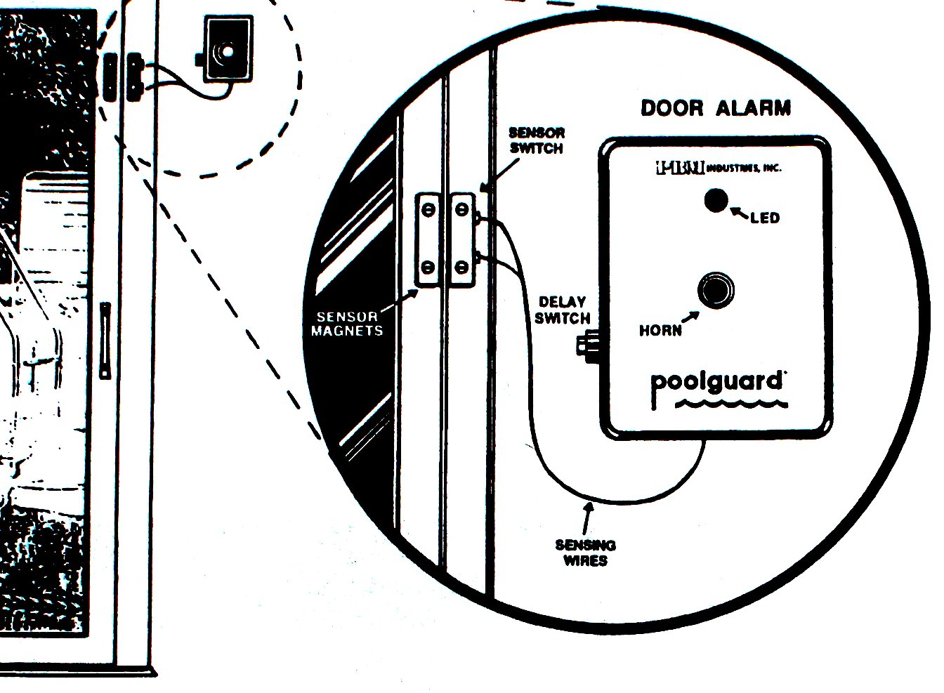
The Poolguard door alarms, which are fitted to all the doors that exit to the pool area, allow you 7 seconds to exit or enter the pool area.

- Open door
- Go through the door
- Push the delay switch on the alarm control box
- Close the door

If the door is left open longer than 7 seconds the alarm will sound continuously. To stop the alarm:
- Push the delay switch on the alarm control box
- Close the door
If the door is left open the alarm will sound again!

Restaurants and Cafes
At the Berry Town shopping area (turn left out of Westridge onto Hwy 27 north and at the first traffic lights turn left into the shopping area where you will find an English Fish and Chips, Chinese takeaway, Pizza and an Appleby’s. Publix also make some excellent subs and fried chicken. Publix is our preferred supermarket for virtually all groceries and it’s close at hand. A little further north will bring you to Cagans Crossing where you will find more restaurants and café’s including Chilis , Taco Bell and Gators.
Travelling south on Hwy 27 will take you past many fast food restaurants that we haven’t yet had the time to try. You will find Denny’s barbeque, McDonalds, Wendy’s, and Waffle House etc.
To go into a major eating area you can turn left out of Westridge onto Hwy 27 north and keep going until you pass Polo Park on your right and then take the next junction which is signed to Disneyworld and Hwy 192. Hwy 192 is an extremely long road with restaurants and shops all the way along it. There are marker points at approximately mile intervals and you can find maps in the supermarkets (free in the coupon booklets) with the markers shown and some of the main restaurants listed.
For good steaks and shrimps we like the Outback Steakhouse, for excellent Italian food try Carrabba's Italian Grill, for Mexican food Chevys Fresh Mex® Mexican Restaurant is great and for a huge buffet breakfast try Shoney's. Fish lovers should try the Bonefish Grill on Sandlake Road their “bang bang shrimp” starter is huge, mildly spicy and really excellent! A large family buffet with steaks, chicken and seafood plus eat as much as you like salads can be found at Sizzler USA or Golden Corral Family Buffet and Grill. All the above can be found on the 192 and in various other locations around Orlando.
These are just a few of the restaurants we have tried but there are many others. If you try a good one please let us know about it and we’ll check it out on our next visit and add it to our list.

Rubbish/Trash
Please place all trash, securely tied in plastic bags, in the bin provided by the garage, to the right side of the house (when viewed from the road). For strong smelling items like leftover food double wrapping using plastic supermarket bags is advisable to help keep the racoons away.
Collections are on Thursday, between 6am and 9am. Please place the bin at the curbside on those mornings by 6am (if you’re not normally awake that early then you can put them out the night before).

Security
Please ensure that all external doors are securely locked and the security bars are in the rails of the sliding doors, whenever you leave the property.
The door from the second bathroom to the pool area is a common one to be forgotten, please check it before you go out. Please do check that the door from the laundry to the games room/garage is locked. Also please check that all windows are closed and secured.
The front door is locked by pressing the button in the centre of the keypad, the one with the picture of a padlock on it.
Please do not allow strangers/contractors into the property unless prior arrangement has been made. If it is necessary for a member of the management company to enter the villa during your stay they will let you know.
The glass sliding doors and the door from the second bathroom to the pool are all fitted with pool alarms. These are fitted for your family’s safety and they must NOT, under any circumstances, be tampered with.

Smoking
Our home is non-smoking so we would appreciate your not smoking in doors. Smoke detectors are fitted in all rooms. Smoking in the villa will incur a charge (deductible from your security deposit) for extra cleaning of carpets and upholstery to remove any residual odours.

Sony Playstation 2
A Playstation 2 is provided for use by our guests both young and old who enjoy relaxing by playing a computer style game. The controllers are stored in the cupboard of the entertainment unit, please return them after use. A few games are provided for your enjoyment. Games can also be rented locally – see the TV section.

Sunbathing
It is against Florida Law to sunbathe topless.

Telephone
The telephone number here is 863-420-2982. You may make local calls free of charge by simply dialing the number.
For national or international calls please dial 863-594-1376/7 and follow the instructions given to place your call. Details of account balance and minutes available are given before you are asked to dial.
Emergency calls are 911 in the USA (not 999).

Television and DVD/CD’s
All televisions are connected to Brighthouse Cable Service.
The 42” High Definition Plasma television in the family room is connected to Brighthouse High Definition Digital Cable with over 300 channels. A scrolling menu is available on this television. Please note that “Pay per view” channels are not available.
The televisions in the games room and both master bedrooms have the same basic cable channels and a printed list should be found in one of the drawers in each room.
If you have your laptop computer connected to our high speed wireless internet service you can find detailed channel lineup on http://www.tvguide.com/listings/index.asp?
Choose the Winter Haven - Brighthouse channels.
To operate the television in the family room:
On the Brighthouse remote control press the Master Power button to turn on both TV and digital cable receiver. If this does not turn them both on press the TV button and then the Master Power button and the Cable button then Master Power button.
To read the menu press the Guide button then select the channel required by pressing the Select button. Alternatively you can scroll through channels with the up/down buttons or type in the channel number required. Please note that Movies on demand and all pay per view channels are not available.
To operate the DVD player
With the TV switched on as above press the DVD button, open the DVD tray by pressing the Open button and place a DVD onto the tray then close the tray. Press the play button on the handset. When you have finished watching a DVD, press the CBL button on the TV handset again to return to cable TV viewing and switch off both TV and DVD player.
A separate DVD remote is also provided in case you find the single unit complicated to operate.
Several DVD’s and CD’s are provided for your entertainment. Please return these to the drawers after use.
DVDs are fairly cheap in the USA and can be purchased readily from Walmart (a few miles north on Hwy 27 – turn left on exiting Westridge and it is on the right just past the 192 junction.
You will find several DVDs and Playstation games in the wicker chest to the right of the television at ground level.
To operate the television in the games room, press the Power key then select channels by keying the channel number or by scrolling with the up/down keys. If the channel does not change by either method press the TV button and then it will.
To operate the television in the master bedroom room, press the Power key then select channels by keying the channel number or by scrolling with the up/down keys.

Toilets
Florida sewerage systems cannot take anything other than a minimal amount of toilet tissue. To avoid overflowing please do not put any of the following items in the bowl:
Baby wipes Diapers/Nappies Kleenex/Tissues
Hair Personal hygiene products Plastic wrappers
The cost of calling a plumber due to misuse will be charged to you.

Towels
Plain coloured towels are provided for the bathroom and patterned ones for use by the pool can be found in the linen cupboards in the master bedroom, and between the two twin bedrooms. It will be greatly appreciated if you could please wash and dry the pool towels and replace in the linen cupboards after use. Villa towels must NOT be used for the beach!

Vacuum Cleaner
A vacuum cleaner is provided for you to clear up any random crumbs, etc. It will help keep ants and other insects away if you spare a few minutes to do this.

Washer/Dryer
A washer and dryer are provided for your convenience.
Please do NOT wash comforters (quilts) in the machine as they are all too large and will come out looking worse than they went in.
In the event of an emergency requiring the laundering of the comforter (quilt) please take it to a coin operated Laundromat. There are several on the 192 and personally I prefer the one a little way past mile marker 15 on the corner of John Young Parkway (the 17/92) the name of which is Coin-a-Magic. The cost is around $6 for a very large wash.

Waste Disposal Unit
This is built into the right hand sink. Please NEVER use it without a constant flow of water. The unit should be used to dispose of small bits of soft organic material when rinsing plates after a meal but NO bones or metal objects.
Please keep the cover in place when not in use as any foreign objects (e.g. dishcloth or cutlery) that fall into the unit will cause it to malfunction and may necessitate an expensive repair!

Water
Florida water is fine to drink but if you prefer bottled water it is readily available at all supermarkets. The filtered and chilled water from the refrigerator dispenser tastes just like normal water. We recommend that whatever water you choose, you take plenty in the car with you when going on a long journey and take some into the theme parks as they charge greatly inflated prices for bottles there.

Be safe and enjoy your holiday

